Recommendations:

1) Genre Int
2) Genre Binary
3) Genome-1128
4) Genome-lemmatized
5) CB-Genome-1128
6) CB-Genome-lemmatized

Parameters for different combinations of recommendations:
Different Values for K movies.
Different Values for relevant_movies_threshold
Different weights for cluster score, rating, diversity and sim to user profile.

Combinations for different genome value cut-down thresholds:

Experimental Setup:
Directory Structure:

ml20m:
output/user_genome_term_vector
output/user_stemmed_genome_term_vector
output/user_genre_binary_term_vector
output/user_genre_aggregated_term_vector
genome-scores.csv
movies.csv
ratings.csv

serendipity2018:
output/user_genome_term_vector
output/user_stemmed_genome_term_vector
output/user_genre_binary_term_vector
output/user_genre_aggregated_term_vector
tag_genome.csv
movies.csv
training.csv

Dataset: ml-20m setup
# load all movies in df,
# load tag-genome scores df
# filter movies only under tag-genome df
# filter-out movies with (no genres listed)
# store final list of movie ID's
# udpate genome_scores_df, ratings_df and movies_df to only keep updated movie ID's

# Updating/Loading user term vectors and movie term vectors

Diversity Calculation:

1)
Div =~ DivMoods + DivSimilar + DivTastes + DivVaried
Nov =~ NovUnexpected + NovFamiliar + NovUnthought
Div ~ Nov + SimRatio
- Ekstrand_umn_0130E_15142.pdf – page 188

2) Intra-list similarity
3) Average similarity of a list to the user’s profile

3) Intra-list dissimilarity:

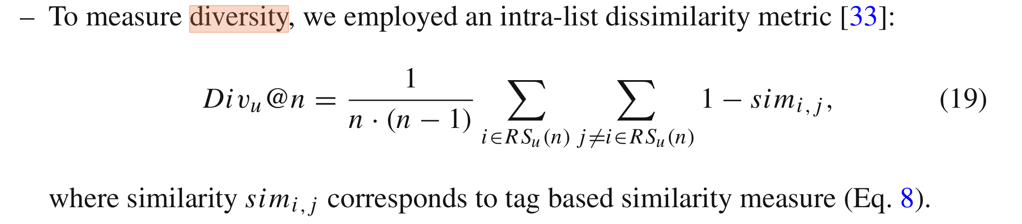
- Kotkov2018_Article_HowDoesSerendipityAffectDivers.pdf, Page 14

4) Dissimilarity to user profile:
d(i, j) = 1 - S_{u}
5) Clustering based diversification (diversity.pdf)
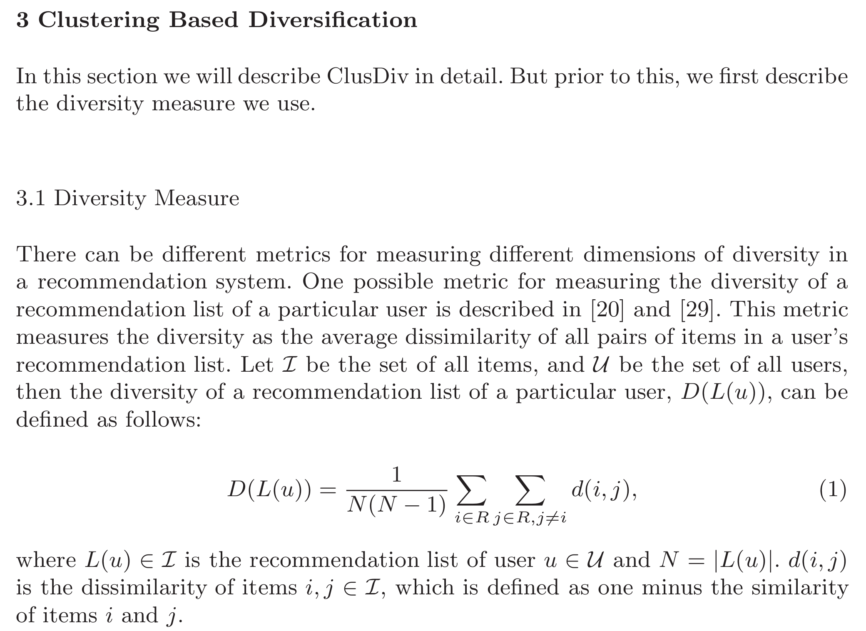

Experimental Setup:

Baseline Recommender:

R1 = Relevance Scores : [r1, r2, ..., r_{n}]
D1 = Diversity: [d1, d2, ..., d_{n}]

Proposed Method Recommender:
R2 = Relevance Scores : [r1, r2, ..., r_{n}]
D2 = Diversity: [d1, d2, ..., d_{n}]

Evaluation Metrics:

Evaluate scores of results among proposed method and baseline recommender using following metrics:

diversity-in-top-N:
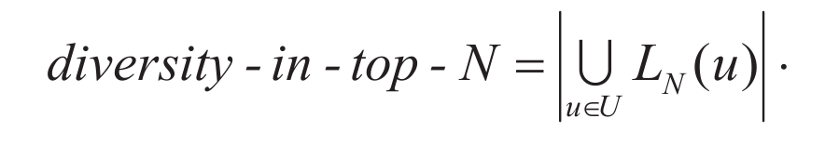

Gap-metric:
- It is calculated by dividing the difference between the value of similarity and diversity by the similarity.
- Gap Metric for r1 & d1:
  - (r1 – d1) / r1

Diversity of a list: (Exploring)
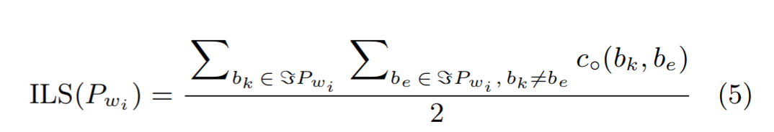

α-nDCG (Exploring):

